FEA 1

Created the hand grinder in APDL as beam elements. Created lines with section definitions given in packet. Drill case was 4in diameter shafts, the bit was 1in diameter, shaft, and the disk was a .5x.5in square beam. This created the geometry shown below

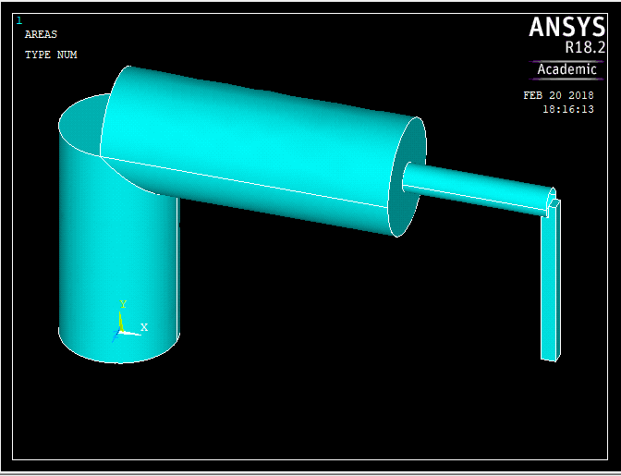

The line elements were meshed and the drill case shafts were given 0 displacement with 50lb forces applied at the base of the handle in the x direction, a -50lb force applied at bottom of disk in the x-direction, and a 25lb force in the -z direction. This resulted in the following plot for reaction forces:

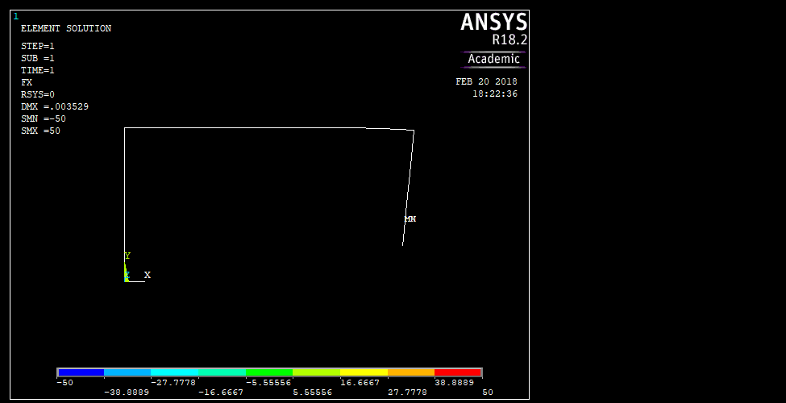

The Forces in X,Y,Z at each element are shown below as are the moments.

PRINT F ELEMENT SOLUTION PER ELEMENT

\*\*\*\*\* POST1 ELEMENT NODE TOTAL FORCE LISTING \*\*\*\*\*

LOAD STEP= 1 SUBSTEP= 1

TIME= 1.0000 LOAD CASE= 0

THE FOLLOWING X,Y,Z FORCES ARE IN GLOBAL COORDINATES

ELEM= 1 FX FY FZ

6 0.0000 0.0000 0.0000

8 0.0000 0.0000 0.0000

ELEM= 2 FX FY FZ

8 0.0000 0.0000 0.0000

9 0.0000 0.0000 0.0000

ELEM= 3 FX FY FZ

9 0.0000 0.0000 0.0000

7 0.0000 0.0000 0.0000

ELEM= 4 FX FY FZ

7 0.0000 0.0000 0.0000

11 0.0000 0.0000 0.0000

ELEM= 5 FX FY FZ

11 0.0000 0.0000 0.0000

12 0.0000 0.0000 0.0000

ELEM= 6 FX FY FZ

12 0.0000 0.0000 0.0000

13 0.0000 0.0000 0.0000

ELEM= 7 FX FY FZ

13 0.0000 0.0000 0.0000

14 0.0000 0.0000 0.0000

ELEM= 8 FX FY FZ

14 0.0000 0.0000 0.0000

10 0.0000 0.0000 0.0000

ELEM= 9 FX FY FZ

10 -50.000 -0.18106E-012 -25.000

16 50.000 0.18106E-012 25.000

ELEM= 10 FX FY FZ

\*\*\*\*\* POST1 ELEMENT NODE TOTAL FORCE LISTING \*\*\*\*\*

LOAD STEP= 1 SUBSTEP= 1

TIME= 1.0000 LOAD CASE= 0

THE FOLLOWING X,Y,Z FORCES ARE IN GLOBAL COORDINATES

16 -50.000 -0.20789E-012 -25.000

17 50.000 0.20789E-012 25.000

ELEM= 11 FX FY FZ

17 -50.000 -0.13412E-012 -25.000

15 50.000 0.13412E-012 25.000

ELEM= 12 FX FY FZ

15 -50.000 0.0000 -25.000

19 50.000 0.0000 25.000

ELEM= 13 FX FY FZ

19 -50.000 -0.81683E-013 -25.000

20 50.000 0.81683E-013 25.000

ELEM= 14 FX FY FZ

20 -50.000 0.81683E-013 -25.000

18 50.000 -0.81683E-013 25.000

PRINT M ELEMENT SOLUTION PER ELEMENT

\*\*\*\*\* POST1 ELEMENT NODE TOTAL FORCE LISTING \*\*\*\*\*

LOAD STEP= 1 SUBSTEP= 1

TIME= 1.0000 LOAD CASE= 0

THE FOLLOWING X,Y,Z FORCES ARE IN GLOBAL COORDINATES

ELEM= 1 MX MY MZ

6 0.0000 0.0000 0.0000

8 0.0000 0.0000 0.0000

ELEM= 2 MX MY MZ

8 0.0000 0.0000 0.0000

9 0.0000 0.0000 0.0000

ELEM= 3 MX MY MZ

9 0.0000 0.0000 0.0000

7 0.0000 0.0000 0.0000

ELEM= 4 MX MY MZ

7 0.0000 0.0000 0.0000

11 0.0000 0.0000 0.0000

ELEM= 5 MX MY MZ

11 0.0000 0.0000 0.0000

12 0.0000 0.0000 0.0000

ELEM= 6 MX MY MZ

12 0.0000 0.0000 0.0000

13 0.0000 0.0000 0.0000

ELEM= 7 MX MY MZ

13 0.0000 0.0000 0.0000

14 0.0000 0.0000 0.0000

ELEM= 8 MX MY MZ

14 0.0000 0.0000 0.0000

10 0.0000 0.0000 0.0000

ELEM= 9 MX MY MZ

10 150.00 125.00 -300.00

16 -150.00 -83.333 300.00

ELEM= 10 MX MY MZ

\*\*\*\*\* POST1 ELEMENT NODE TOTAL FORCE LISTING \*\*\*\*\*

LOAD STEP= 1 SUBSTEP= 1

TIME= 1.0000 LOAD CASE= 0

THE FOLLOWING X,Y,Z FORCES ARE IN GLOBAL COORDINATES

16 150.00 83.333 -300.00

17 -150.00 -41.667 300.00

ELEM= 11 MX MY MZ

17 150.00 41.667 -300.00

15 -150.00 -0.35527E-014 300.00

ELEM= 12 MX MY MZ

15 150.00 0.73306E-014 -300.00

19 -104.48 -0.73306E-014 208.97

ELEM= 13 MX MY MZ

19 104.48 0.73306E-014 -208.97

20 -54.621 -0.73306E-014 109.24

ELEM= 14 MX MY MZ

20 54.621 -0.24046E-013 -109.24

18 0.35527E-013 0.24046E-013 0.13500E-012